This is a walk through on how to setup events and lanes in Velocicast. You will need to do this each week for your sales. Please let me know if you have any questions or concerns?

Step 1
- Click on the Events tab
- 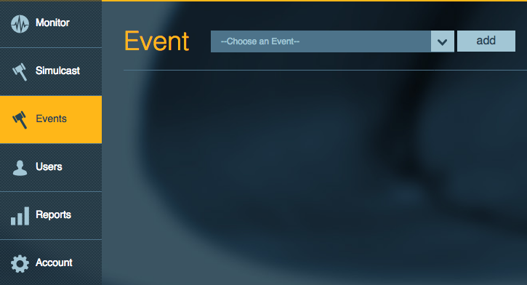
Step 2
- Click on add
- 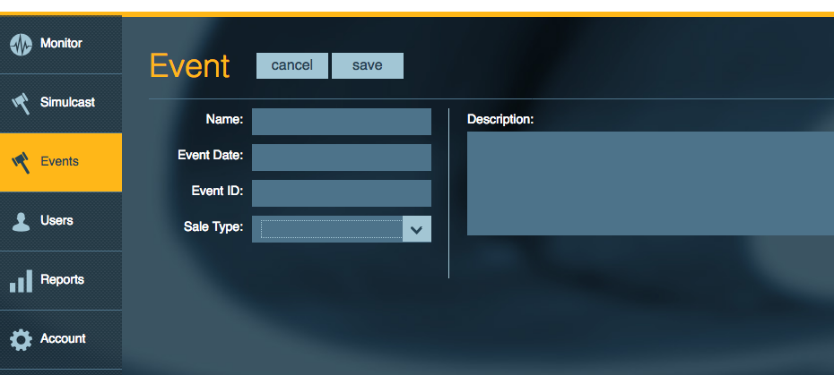
- Fill out the Name of the Event
- click on the event date field and select a date
- Get your Event ID from Vero and enter it here I sent you a PDF previously on how to find this in Vero. Just incase you do not have it I included it as an attachment on this email.
- Select a sales type
- Add an description if desired
- 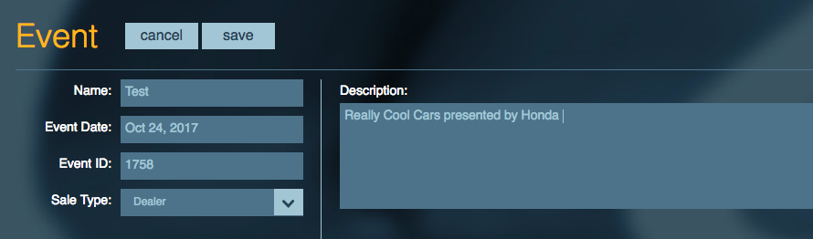
- Click on save
Step 3
- Select the event that you just created from the drop down menu
- 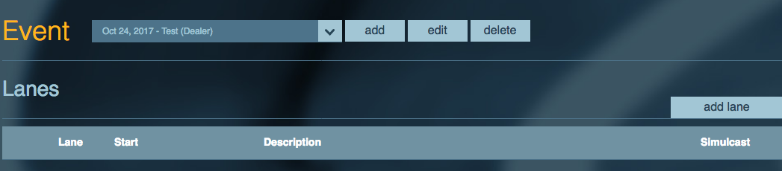
- Click on add lane
- Add the short name, name, description and start time
- 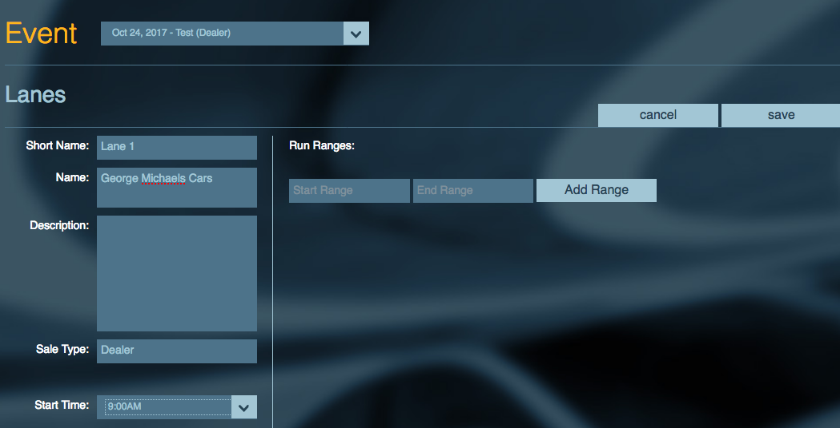
- Add the range of item numbers that need to be setup in this lane i.e. A001 - A100 just make sure it has the low and the high item numbers of the items you are planning on running in this lane.
- Click on Add Range when done
- 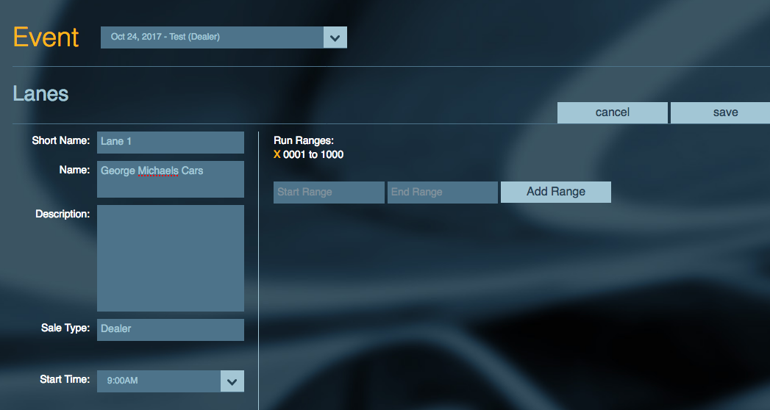
- Add any additional run ranges.
- Click on save.
Step 4
- Click on add lane and repeat the steps to create your additional lanes
- 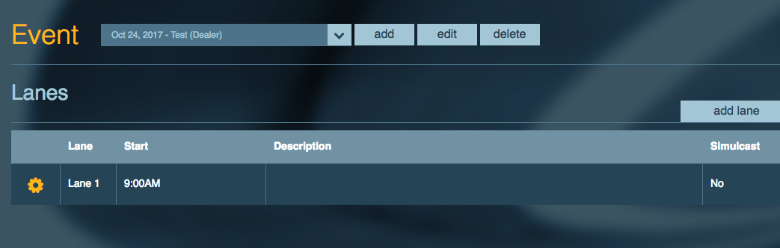
Step 5
- Click on the gear icon for each lane to Build on Simulcast
- 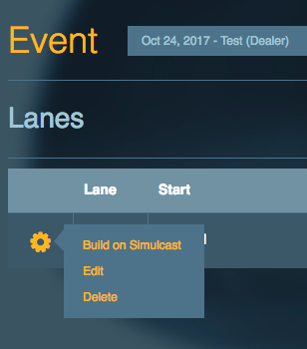
- You can also Edit or Delete the lanes from here as well.

